Cushing Association

Minutes: Meeting took place Sunday, 25 August 2024, 18:00hrs CST; All members in attendance (Except for Amy) Justin Craven was in attendance.

- Reunion Planning/Fundraising:
  - Justin Craven participated in the meeting since he lives in the Seattle area. Justin offered his services to conduct some research for potential facilities to host the reunion. He will join us next meeting to provide an update on his efforts.
  - Total Revenue $735.32 (Total Sales – Total Costs)
  - The board discussed acquiring the services of Cory Clabaugh for providing items for the live auction at the 2025 reunion. Cory has done quality work for the organization in the past and the board wanted to continue the partnership. Jon Moulton will be reaching out to Cory about his availability and will provide an update in the September meeting.
  - Merchandise Sale: 2024
  - Total Sales $1908.04
  - Merchandise Purchase $933.33
  - Shipping Costs $197.95
  - Packaging Costs $41.44
  - Total Costs $1172.72

- Website/Bluhost:
  - Date Cost Service
  - 1/23/2024 $ 7.99 1 Month Micro Soft 365 License
  - 2/23/2024 $ 7.99 1 Month Micro Soft 365 License
  - 3/23/2024 $ 7.99 1 Month Micro Soft 365 License
  - 4/23/2024 $ 7.99 1 Month Micro Soft 365 License
  - 5/23/2024 $ 7.99 1 Month Micro Soft 365 License
  - 6/23/2024 $ 7.99 1 Month Micro Soft 365 License
  - Bluehost provides the Cushing Association website
services. Gabriel Stokes pays these monthly and
annual costs. Gabriel is reimbursed from the PayPal
account. These transactions are identified as Service
Payments in the account ledger.

- Financial Report (1st and 2nd Quarters):
  - Gabriel Stokes gave a presentation and shared documentation with the Board of Directors in reference to the financial efforts of the organization.
  - PayPal Activity Ledger:
    - Beginning of 1st QTR Balance $3704.64
    - End of 2nd QTR Balance * $6041.17

- 2023-2024 Final Dues Report:
    - Number Paid - 19
    - Total Revenue - $971.70

- Review of Timeline:
    - The board discussed the budget and decided to move forward and start working on the future goals for the reunion (timeline can be seen below).
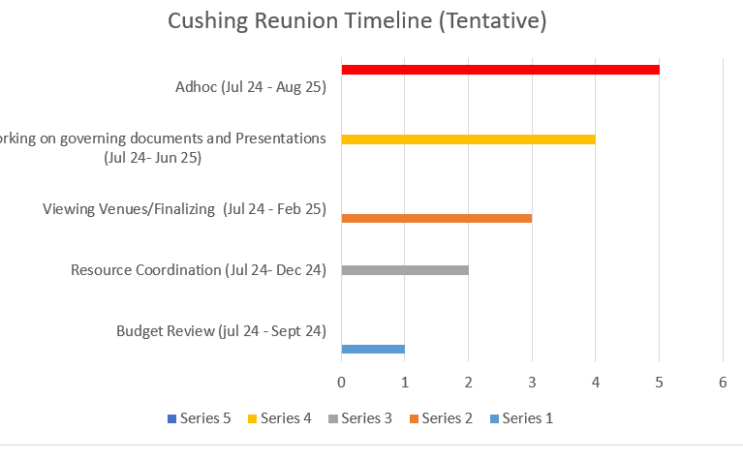
- Round Table:
    - Zach Trublood is researching on the potential purchase of Cushing patches to sale at the reunion. He will provide an update at the September meeting.

- Next Board Meeting: Sunday, 22 September 2024, 18:00hrs CST

