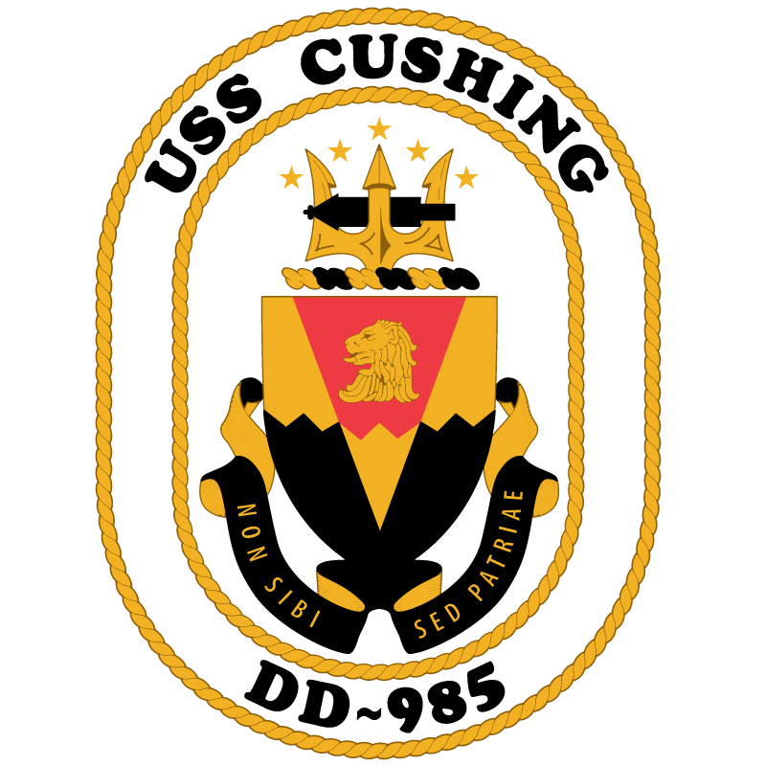 Cushing Association

Minutes: Meeting took place Sunday, 1 March 2026, 18:00hrs CST;
Board Members in attendance Shannon Mickens-President, Jon Moulton-Vice President, Cat Bartrug-Treasurer, Amy Laetzsch-Secretary, (Zach Trueblood-Historian was not available), Gene Lavastida-Head of the Planning Subcommittee.

- Naming of a new ship:
  - The physical copy of the letter to be sent to Navy (SECNAV) is currently in rotation via USPS for all association board members to sign.

- Reunion Planning:
  - 4 out of 5 board members voted Yes and welcomed Gene Lavastida as Head of the Planning Subcommittee for the Nashville reunion.
  - Gene Lavastida is helping to scout venues for the reunion.
  - Jon will conduct surveys on social media to narrow down the date for the reunion.

- Monthly Financial Report:
  - Cat is awaiting a response from the IRS regarding getting our EIN reinstated.
  - Cat is currently setting up a Drop Box to house documents. She will coordinate this effort with Zach. Links will be sent to all board members for access.
  - Grants:
    - Cat has been looking into options for the association to apply for grants. Shannon and the remaining board members have been in full support of these efforts. Shannon has been working closely with Cat in these endeavors. The board will create clear and concise guidelines, criteria and bylaws.
  - Projected Budget:
    - Cat is inputting historical data and will bring this to the board once she has completed the task.

- Website/Social Media:
  - Jon and Zach to work on adding a link for surveys on the website.
  - Facebook:
    - USS Cushing DD 985 Alumni page will be completely phased out, and we will begin using only the USS Cushing Association page.
  - Mainly we will be using the website over the social media pages for association information and documentation. Encourage members to use the website.

- Fundraising:
  - Artwork: Jon to create social media post to see if any members wish to help with artwork.
  - Once artwork is determined, the board will further discuss what items to order.

- Organization Documents:
  - Shannon structured and presented Dissolution Language for By-laws and approved by the board to present to members at the next reunion.
    - Zach will be posting the Charter and By-laws to the website.
  - Misson Statement:
    - Shannon created 2 options for which the board will vote on at the next meeting.
  - Jon and Zach are working on creating new letterhead for the association.

- Roundtable:
  - The board will be reaching out to association members via social media and email to welcome them to serve on board subcommittees.

- Next Board Meeting: Sunday, 29 March 2026, 18:00hrs CST

